

**C++ PROGRAMMING CODES**

**Made By- SUMAN RAJAK**

1. Even and Odd Checking: -

#include<iostream>

using namespace std;

int main()

{

int n;

cout<<"Enter an Integer:"<<endl;

cin>>n;

if (n%2==0)

cout<<n<<" is even";

else

cout<<n<<" is odd";

return 0;

}

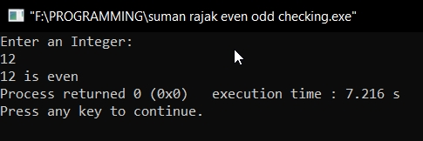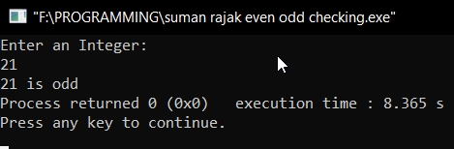

2. Factorial Calculating: -

#include<iostream>

using namespace std;

int main()

{

int num,fact=1;

cout << "Enter a number to calculate Factorial"<<endl;

cin >> num;

if(num>0)

{

for(int i=1; i<=num; i++)

{

fact=fact*i;

}

cout<<"Factorial of the number is:"<<fact;

}

else if (num==0)

{

cout<<"Factorial of 0 is 1";

}

else

{

cout<<"Factorial of a negative number doesn't exist";

}

return 0;

}

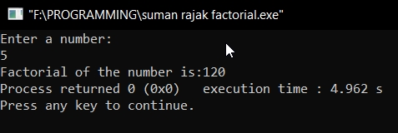

3. Perfect Square Checking: -

#include<iostream>

using namespace std;

int main()

{

int num,perfectsquare=0;

cout<<"Enter a number"<<endl;

cin>>num;

for(int i=1; i<=num; i++)

{

if(i*i==num)

{

perfectsquare=1;

break;

}

if(i*i>num)

{

break;

}

}

if(perfectsquare)

{

cout<<"Input number is a perfect square";

}

else

{

cout<<"Input number is not a perfect square";

}

return 0;

}

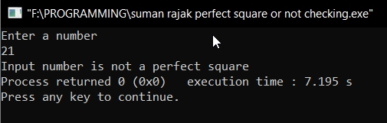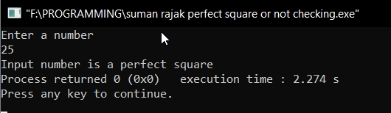

4. Calculating Area and Perimeter of Different Shapes

(Circle, Rectangle, Triangle): -

#include<iostream>

#include<cmath>

using namespace std;

int main()

{

int num;

cout<<"Enter any Number\n 1 for circle\n 2 for rectangle\n 3 for triangle"<<endl;

cin>>num;

switch(num)

{

case 1:

{

float radius,area,circum;

cout<<"Enter value of radius"<<endl;

cin>>radius;

area=3.14*radius*radius;

circum=2*3.14*radius;

cout<<"Area of circle is "<<area<<endl;

cout<<"circumference of circle is "<<circum<<endl;

break;

}

case 2:

{

float length,width,area,perimeter;

cout<<"Enter value of length"<<endl<<"Enter value of Width"<<endl;

cin>>length>>width;

area=length*width;

perimeter=(2*length+2*width);

cout<<"Area of rectangle is "<<area<<endl;

cout<<"Perimeter of rectangle is "<<perimeter<<endl;

break;

}

case 3:

{

float base,height,hypotenuse,s,area,perimeter;

cout<<"Enter value of base\n"<<"Enter value of height\n"<<"Enter value of hypotenuse"<<endl;

cin>>base>>height>>hypotenuse;

perimeter=base+height+hypotenuse;

s=((base+height+hypotenuse)/2);

area=sqrt(s*(s-base)*(s-height)*(s-hypotenuse));

cout<<"Area of triangle is "<<area<<endl;

cout<<"Perimeter of triangle is "<<perimeter<<endl;

break;

default:

printf("Please Enter a Number Between 1 to 3");

}

return 0;

}

}



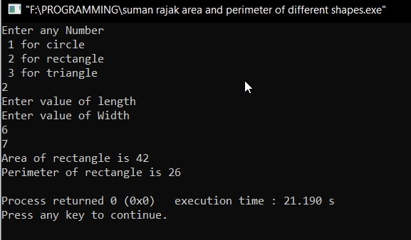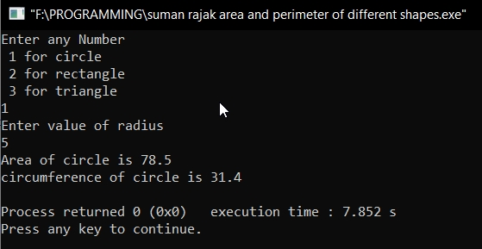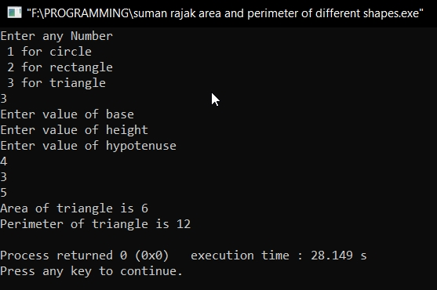

5. Sum of Digits in a Number: -

#include<iostream>

using namespace std;

int main()

{

int n,sum=0;

cout<<"Enter a Number "<<endl;

cin>>n;

while(n!=0)

{

sum=sum+(n%10);

n=(n/10);

}

cout<<"The sum of the digits is "<<sum;

return 0;

}

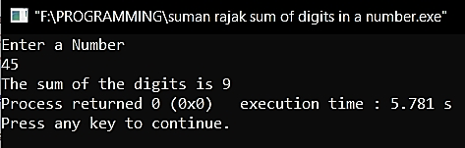

6. Counting the Digits in a Number: -

#include<iostream>

using namespace std;

int main()

{

int N,n=0;

cout<<"Enter a Number to Count Digits\n";

cin>>N;

while(N!=0)

{

N=(N/10);

n++;

}

cout<<"The Number of Digits in this Number = "<<n;

return 0;

}

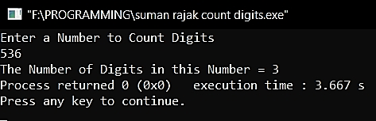

7. Armstrong Number Checking: -

#include<iostream>

using namespace std;

int main()

{

int N=0,n,p,r;

cout<<"Enter a Number"<<endl;

cin>>n;

p=n;

while(p!=0)

{

r=(p%10);

N=(N+(r*r*r));

p=(p/10);

}

if(n==N)

cout<<"The number "<<n<<" is an Armstrong Number"<<endl;

else

cout<<"The Number "<<n<<" is not an Armstrong Number"<<endl;

return 0;

}

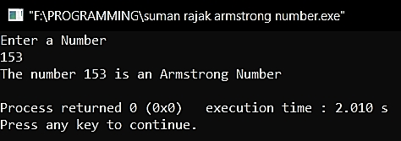

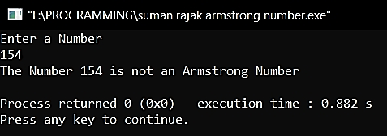

8. nPr Calculating: -

#include<iostream>

#include<conio.h>

using namespace std;

int main()

{

int n,r,s=1,i;

cout<<"Enter the value of n: ";

cin>>n;

cout<<"Enter the value of r: ";

cin>>r;

for(i=0; i<=r-1; i++)

{

s=s*(n-i); //npr= (n-0)(n-1)(n-2)..........(n-(r-1)) Let i= 0,1,......,r-1

}

cout<<endl<<"The value of npr is: "<<s<<endl;

getch();

return 0;

}

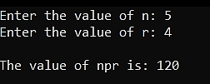

9. nCr Calculating: -

#include<iostream>

#include<conio.h>

using namespace std;

int main()

{

int n,r,s=1,i,j,k=1,p;

cout<<"Enter the value of n: ";

cin>>n;

cout<<"Enter the value of r: ";

cin>>r;

for(i=0; i<=r-1; i++)

{

s=s*(n-i); //npr= (n-0)(n-1)(n-2)..........(n-(r-1)) Let i= 0,1,......,r-1

}

for(j=1; j<=r; j++)

{

k=k*j; //ncr=npr/r factorial

}

p=(s/k);

cout<<endl<<"The value of ncr is: "<<p;

getch();

return 0;

}

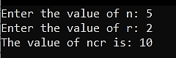

10. Fibonacci Numbers up to n terms: -

#include<iostream>

using namespace std;

int main()

{

int n,a,k,i=0,j=1;

cout<<"Enter the Number of terms: ";

cin>>n;

cout<<"The Fibonacci Series is: ";

cout<<"\n"<<i<<"\n"<<j<<"\n";

for(a=3; a<=n; a++)

{

k=i+j;

i=j;

j=k;

cout<<k<<"\n";

}

}

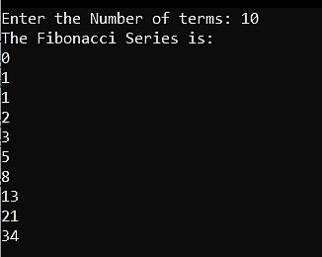

11. Fibonacci Numbers up to n numbers: -

#include<iostream>

using namespace std;

int main()

{

int n,k,i=0,j=1;

cout<<"Enter the Number: ";

cin>>n;

cout<<"The Fibonacci Series is: ";

cout<<"\n"<<i<<"\n"<<j<<"\n";

k=i+j;

while(k<=n)

{

cout<<k<<"\n";

i=j;

j=k;

k=i+j;

}

}

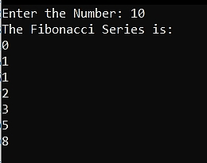

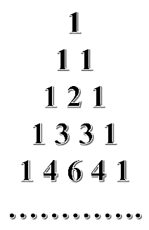12. To Print Pascal’s Triangle: -

#include<iostream>

#include<conio.h>

using namespace std;

int main()

{

int n,r,row,blank,ncr;

cout<<"Enter the Number of Row: ";

cin>>row;

for(n=0; n<row; n++)

{

for(blank=1; blank<row-n; blank++)

cout<<" ";

for(r=0; r<=n; r++)

{

if(n==0||r==0)

{

ncr=1;

cout<<ncr<<" ";

}

else

{

ncr=ncr*(n-r+1)/r;

cout<<ncr<<" ";

}

}

cout<<"\n";

}

getch();

}

